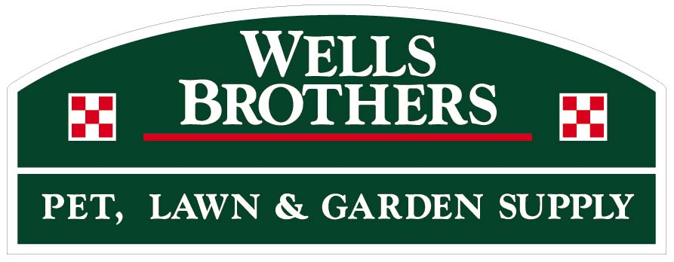

RAISED BED GARDEN KIT

OPTION 1 – 4’ X 4’ X 8”
16’ - 2” THICK ROUGH CUT CEDAR*
8 BAGS CUSTOM ORGANIC MIX
4 BAG TOP SOIL
5# BAG DIRT DIET FERTILIZER
$134.61 +Tax

OPTION 2 – 8’ X 4’ X 8”
24’ – 2” THICK ROUGH CUT CEDAR*
16 BAGS CUSTOM ORGANIC MIX
8 BAGS TOP SOIL
10# BAG DIRT DIET FERTILIZER
$233.49 +Tax

OPTION 3 – 12’ X 4’ X 8”
32’ – 2” THICK ROUGH CUT CEDAR*
24 BAGS CUSTOM ORGANIC MIX
12 TOP SOIL
15# BAG DIRT DIET FERTILIZER
$322.92 +Tax

*All lumber is pre drilled and includes hardware

